UNIVERSITY OF WAH (UOW)

DEPARTMENT OF COMPUTER SCIENCE



COURSE TITLE: INTRO TO INFORMATION SECURITY

COURSE CODE: CS – 251 L

SUBMITTED TO: MS. WASIFA KANWAL

SUBMITTED BY: SAADI SAFDAR

REG #: UW-24-CS-BS-088

BSCS 3RD B

LAB ASSIGNMENT # 11

Diffie-Hellman Code:
p = 101
g = 88

xa = 4
xb = 7

ya = pow(g, xa, p)
yb = pow(g, xb, p)

print(f"Alice's public key: {ya}")
print(f"Bob's public key: {yb}")

k_alice = pow(yb, xa, p)
k_bob = pow(ya, xb, p)

print(f"Alice's calculated shared secret: {k_alice}")
print(f"Bob's calculated shared secret: {k_bob}")

Output:

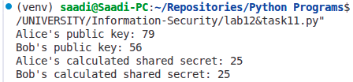

RFS Code:

def modInverse(e, phi):
for d in range(2, phi):
if (e * d) % phi == 1:
return d
return -1

# RSA Key Generation
def generateKeys():
p = 61
q = 53

n = p * q
phi = (p - 1) * (q - 1)
# Choose e, where 1 < e < phi(n) and gcd(e, phi(n)) == 1
e = 0
for e in range(2, phi):
if gcd(e, phi) == 1:
break
# Compute d such that e * d ≡ 1 (mod phi(n))
d = modInverse(e, phi)
return e, d, n

# Function to calculate gcd
def gcd(a, b):
while b != 0:
a, b = b, a % b
return a

# Encrypt message using public key (e, n)
def encrypt(m, e, n):
return pow(m, e, n)

# Decrypt message using private key (d, n)
def decrypt(c, d, n):
return pow(c, d, n)

# Key Generation
e, d, n = generateKeys()

print(f"Public Key (e, n): ({e}, {n})")
print(f"Private Key (d, n): ({d}, {n})")

# Message
M = 123
print(f"Original Message: {M}")

# Encrypt the message
C = encrypt(M, e, n)
print(f"Encrypted Message: {C}")

# Decrypt the message
decrypted = decrypt(C, d, n)
print(f"Decrypted Message: {decrypted}")

Output:

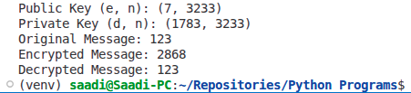
Dry Run:

